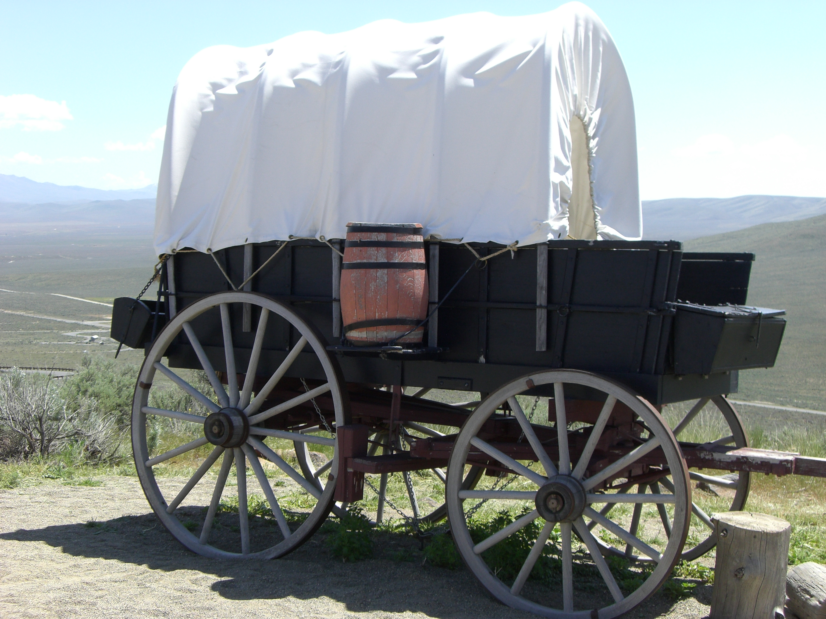
Pioneers of Recovery

People Getting Relief from the Symptoms
of
Parkinson's Disease

